Dance Registration System

Testing Manual

Group Number: 2

CPSC 488 Section 01

**TABLE OF CONTENTS**

**1 INTRODUCTION………………………..……………………………………………………3**

* 1. DESCRIPTION……………………………………………………………………………….3

**2 HUMAN FACTOR TESTING..……………………………………………………………....3**

2.1 LOGIN ………………………………...……………………………………………………...3

*2.1.1 Bad Credentials*…………………..…………………………………………........*.*...3

*2.1.2 Insufficient Passwords*………..………………………………………......................4

2.2 UPLOAD EXCEL FILES……..…...……………………………………………………….…**4**

*2.2.1 Valid File Check* …………………..…………………………………………......*.*...4

*2.2.2 Valid Data Check*………..………………………………………………………......5

*2.2.3 Missing File Upload*………..…………………………………….……..………......5

**3 BOUNDARY ANALYSIS...…………………………………………...……………………....6**

3.1 BOUNDRY CHECKS……………………....………………………………………………...6

*3.1.1 Excel Boundary Limits….*……..……………………………………………..…......*.*6

*3.1.2 Payment Boundary*…………………………………………………………….….....6

**4 STRESS TEST...……………………………………………………………….……………....7**

4.1 SERVER……………………...………………………………………………..……………...7

*4.1.1 Overloading….*……..………………………………………………………...…......*.*7

4.2. EXCEL UPLOAD……………………………………………………………………...….....7

*4.2.1 Excessive Upload….*……..…………………………………………..…………......*.*7

**5 UNIT TEST...…………………………………………………………………………..……....7**

5.1 UNIT TESTS……………………...………………………………………...………………...7

*5.1.1 Available….*……..………………………………………………………………......*.*7

**6 INTEGRATION TEST...…………………………………………...………………………....8**

6.1 INTEGRATION TESTS…………………...…………………………………………….…...8

*6.1.1 Available….*……..………………………………………………………………......*.*8

**7 BLACK BOX TEST...………………………………………………………………………....8**

7.1 BLACK BOX TESTS…………………...………………………..…………………………...8

*7.1.1 Quality Control….*……..………………………………………………….……......*.*8

**8 WHITE BOX TEST...………………………………………………………………………....8**

8.1 WHITE BOX TESTS…………………...………………………………………………..…...8

*8.1.1 User Interface….*……..…………………………………………………………......*.*8

*8.1.2 Input Files….*……..…………………………………………………………..…......*.*8

*8.1.3 Application Connection.*……………………………………………………..…......*.*8

**1 INTRODUCTION**

**1.1 Description**

This manual details the testing implemented throughout the program. Throughout the document, explanations depict how testing was performed and solutions to errors when they were uncovered.

Following this introduction, testing pertaining to human-factor errors, boundaries, stress test, unit, integration, and black and white box testing is described. These tests pertain to the program functionalities such as the abilities of uploading excel files.

**2 HUMAN FACTOR TESTING**

**2.1 Login**

2.1.1 Bad Credentials

Commonly, when a user logs in their passwords and emails are checked for correspondence to existing users. When either the password or email is incorrect, does not match expected values, or is non-existing, the user will see the message:

2.1.2 Insufficient Passwords

Upon the user’s first logon, they are required to change the password. The password must meet standard password security practices. If the password does not match the requirements, the following is displayed:

**2.2 Upload Excel Files**

2.2.1 Valid File Check

To avoid alternative files being loaded into the program, there is validation check in place. This check scans the first cell of each file for a specific value that must match one hard-coded into the program. The program will not read further or upload files that do not contain the specific value. The error is shown below:

2.2.2 Valid Data Check

If the data uploaded is not the correct format or data types, the HTML will show simple error messages of incorrect types:

2.2.3 Missing File to Upload

If a user selects the button upload before selecting a file to be uploaded, the program throws a simple error message:

**3 BOUNDARY ANALYSIS**

**3.1 Boundary Checks**

3.1.1 Excel Boundary Limits

As any business would aspire to continually grow, the size of the excel files uploaded has been dynamically assigned. It has been assumed that the number of children, parents, instructors, etc. will grow, therefore the sizes are found by the number of rows and columns.

3.1.2 Payment Boundary

When making a payment on a parent’s account, there is the possible to overpay. To accommodate this, the parent’s account is credited the overpayment. This will show as a negative balance, meaning they do not owe that amount. The calculations of balances should take this into account in future work.

From the Manager’s view:

From the Parent’s view:

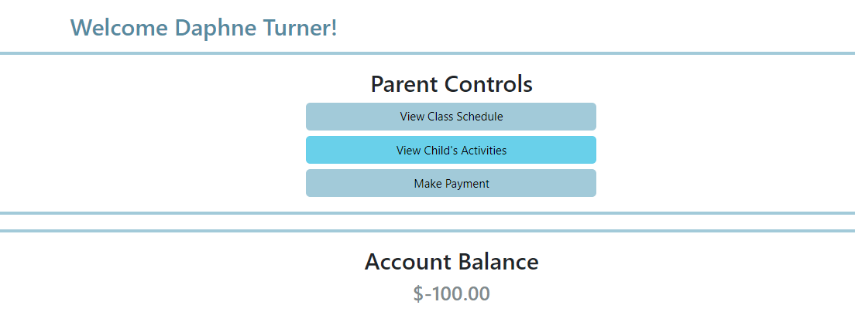

**4 STRESS TESTING**

**4.1 Server**

4.1.1 Overloading

At this time, the program solely runs on the localhost:8080. Therefore, only one user at a time can be logged in and performing operations.

**4.2 Excel Upload**

4.2.1 Excessive Upload

Each excel upload has its own HTML webpage, therefore only one excel file can be uploaded at a time. The program can not upload an excessive amount. The database will refresh with new data if a file is re-uploaded.

**5 UNIT TESTING**

**5.1 Unit Test**

5.1.1 Available Tests

The Unit Tests can be found for their respective files in the following packages accordingly:

* src/test/java
  + edu.sru.thangiah.group2.fall2023registrationsystem.controller.test;
  + edu.sru.thangiah.group2.fall2023registrationsystem.domain.test;
  + edu.sru.thangiah.group2.fall2023registrationsystem.service.test;
  + edu.sru.thangiah.group2.fall2023registrationsystem.model.test;
  + edu.sru.thangiah.group2.fall2023registrationsystem.LoginPage.test;
  + edu.sru.thangiah.group2.fall2023registrationsystem.test
  + edu.sru.thangiah.group2.fall2023registrationsystem.config.test
  + edu.sru.thangiah.group2.fall2023registrationsystem.security.test

**6 INTEGRATION TESTING**

**6.1 Integration Test**

6.1.1 Successful Mappings

To navigate throughout the UI, the user must click through buttons. All of the buttons correctly and successfully correspond to their mappings at this time. The data passed through these are successfully carried.

**7 BLACK BOX TESTING**

**7.1 Black Box Test**

7.1.1 Quality Control

The excel files are parsed and loaded into the program. Once loaded they make the correct associations to display the data on the HTML. Through the mappings the data carried through correctly at this time.

**8 WHITE BOX TESTING**

**8.1 White Box Test**

8.1.1 User Interface

Extensive testing has and will continue to be executed on the program to ensure successful functionality across all areas of the UI.

8.1.2 Input Files

The Admin’s file to upload is the first required upload. This uploads enrolls managers into the program. Managers can then upload all other files in any order.

8.1.3 Application Connection

At this time, all applications connect successfully when the program is executed. The database connection is automated successfully and the localhost connection is permitted while the eclipse project is steadily running.